Oliver Schramm
Dr. Matt Stuart
STAT 408: Applied Regression Analysis
3 December 2025

Predicting Political Violence in the United States
For this project, I wanted to build a logistic regression model that could predict whether or not a Far-Left, Far-Right, or Single–Issue radicalized individual in the United States would participate in or commit an act of political violence. The dataset that I used to train this model is the Profiles of Individuals Radicalized in the United States (PIRUS) dataset from the University of Maryland's National Consortium for the Study of Terrorism and Responses to Terrorism (START). PIRUS contains exhaustive information about extremist plots, activities, radicalization sequences and details, and demographics across 124 variables for 3,526 exposed extremists. This project is relevant to the current political climate in the United States. Extremism influenced by political leaning has seen a rise in the 21st Century, and violent acts motivated by these extreme beliefs have also seen a rise. The publicity of this extremism has also increased, with media outlets and politicians spinning extremist activities every which way in order to fit their narrative. My hope is that the predictive models I have built can cut through these narratives and deliver real, unbiased insights into what pushes political extremists to the violent edge.
PIRUS contains a random sample of arrested, indicted, or otherwise publicly exposed extremists who were radicalized in the United States. Each observation is formally deidentified, but several notable domestic terrorist attacks, such as the Oklahoma City Bombing in 1994, the Charleston Church shooting in 2015, the El Paso Walmart shooting in 2019, and the Buffalo Grocery Store shooting in 2022 are discernably included in the dataset. What is notably excluded from PIRUS is the January 6th Insurrection at the United States Capitol Building in 2021, which was excluded because of the massive number of perpetrators who were charged for the attack. Including these perpetrators would add a significant bias to the data. Before I could begin modeling, I had to clean and prepare the data and make the variables easier to interpret, as all of the categorical variables were stored as ordinal numeric variables that would require constant codebook reference to understand. My first step was creating a script to convert these ordinal numeric variables to ordinal character variables. After I completed this, I made a subset of my dataset which removed any variables that would directly inform my response variable, and any irrelevant or variables made up mostly of NAs. After this preparation, my dataset had 2700 observations and 65 explanatory variables.
Once I had curated my data for modeling, I inspected the characteristics of the data, created some visualizations, and calculated summary statistics for the year of exposure and age variables in the dataset, two of the three numeric variables. The earliest observation in the dataset is from 1948, and the most recent observations are from 2022. The average extremist in this sample was exposed in 2007, while the median year of exposure is 2016. There is a vast range of ages in this sample, with the youngest extremist being 15 years old, and the oldest being 88 years old. The average extremist in this sample is 36 years old. Figure 1 shows the distribution of non-violent and violent offenders in the dataset. Figure 2 shows the distribution of non-violent and violent offenders by age group and shows that the majority of the observations are extremists between the ages of 20 and 40 years old, with a combined 1,612 observations. Lastly, Figure 3 confirms the aforementioned rise in political extremism in the 21st century, showing that increasing numbers of people are extreme in their political leanings and are willing to commit violence to further their ideological goals, especially after 2010.
The goal of the models I trained was to predict whether or not a political extremist will plot and/or commit an act of political violence. The criterion I will be choosing to select my best model are the Area Under the Curve (AUC) and Accuracy metrics, as both of these can demonstrate the predictive power of a model, which is my ultimate goal. I will also test my models on the data they were trained on to determine if any overfitting is occurring. For my first model, I trained a logistic regression classification model using all 65 explanatory variables in my subset and an 80/20 test-train split, which I used for all of the subsequent models I trained. When I looked at the summary for this model, I noticed that the model had 24 coefficients out 366 that were not defined due to singularities, and there were fitted values that were numerically 0 or 1. There were also coefficients that were nonsensical in their interpretation. For example, $β_{62}SocialMediaPlatformReddit=15.239$, which would be interpreted as such: The expected odds of an extremist participating in or committing an act of political violence are 4,151,582 times higher for an extremist who was radicalized or mobilized on Reddit, compared to an extremist radicalized or mobilized on blogging sites, holding all other variables constant. It was clear that I needed to perform regularization on my model, so I trained six regularized models. To handle my variable selection issue, I trained two LASSO and Elastic Net models, and to handle coefficient shrinkage, I trained two Ridge models. For all three model types, I performed 10 K-fold cross-validation and trained one model using the estimate of lambda that minimized Mean Squared Prediction Error ($\hat{λ})$, and another using the one-plus standard error estimate of lambda ($\overline{λ}$) as my lambda values and smoothing parameters.
Upon training these models, I extracted the coefficients of each, tested their accuracy on both the train and test to determine model fit, and performed my diagnostic tests. The best model according to my diagnostic tests was the LASSO model with $\overline{λ}$ as the lambda value and smoothing parameter. This model had an AUC of 93.05% and a test accuracy of 85.74%. Something peculiar about this model was that the train accuracy was lower than the test accuracy at 84.21%. The difference between these two is marginal though, and this was the only regularized model I trained where the difference was positive. My runner-up model was the Elastic Net model that was trained with $\overline{λ}$, which had an AUC of 92.7% and a test accuracy of 83.88%. This model was also a great fit for the data, with the difference between the test and train accuracy being just over 1%. The worst model overall was the unpenalized logistic regression model, both in its predictive power It makes sense that the LASSO and Elastic Net models with $\overline{λ}$ performed the best out of all of the models I made, as using the one-plus standard error lambda value will choose a more heavily regularized model. Furthermore, LASSO and Elastic Net models perform variable selection and coefficient shrinkage, whereas Ridge only performs shrinkage. For full details of the model diagnostic scores, number of coefficients, lambda plots, and ROC curves, refer to Figures 4-13.
Now that I have my best model, I want to interpret some of the more interesting and significant coefficients of the 38 explanatory variables (Figure 14) that remained after implementing LASSO regularization. All coefficients will be interpreted as standard odds, rather than log-odds. First off, I want to interpret the intercept of $log\left(\hat{Violent}\right) = -6.653$: The odds that an extremist will participate in or commit an act of political violence are 0.00129, holding all numerical explanatory variables at 0 and all categorical explanatory variables at their baseline. Now, for the strongest predictor in my model, $β_{22}RadicalBehaviorsViolentPlot = 3.281$, there needs to be some discussion. When I first saw this variable in my model, I was concerned that I should have removed it with the other plot-related variables, which were all perfectly indicative of my response variable. RadicalBehaviorsViolentPlot, however is not. Around 33% of the violent extremists observed in the original dataset did not create or contribute to a violent plot but participated in or committed an act of political violence otherwise, and around 3% of the non-violent extremists observed in the original dataset created or contributed to a violent plot but did not participate in or commit an act of political violence. Therefore, this variable can be signified as an extremely strong predictor, but not a perfect predictor, so it should be kept in the model for now. The coefficient is interpreted as follows: The odds that an extremist will participate in or commit an act of political violence are 26.6 times higher for an extremist who created or contributed to a violent plot, compared to an extremist who simply associated with extremists, holding all other variables constant.
Overall, my models were very strong in predicting whether an extremist would participate in or commit an act of political violence, with the LASSO models being the best, Elastic Net being just behind LASSO, and the Ridge and unpenalized logistic regression models rounding out the lower end of predictive power. My intent for these models was to cut through polarized narratives and develop an understanding of what makes an extremist more likely to be violent, and I believe this intent was delivered. If the United States population can better understand domestic political violence, I believe that our abilities to prevent and mitigate it on all sides will be all the stronger. What could make my models and analysis even stronger would be training more advanced predictive algorithms, such as support vector machines, random forest models, and neural networks. I intend on building these models as I develop a further understanding of these models, and hope that the START Consortium publishes an updated version of PIRUS on which I can train these models. With a more robust dataset and advanced predictive models, I believe my predictive power would only increase.

Appendix
Figure 1:
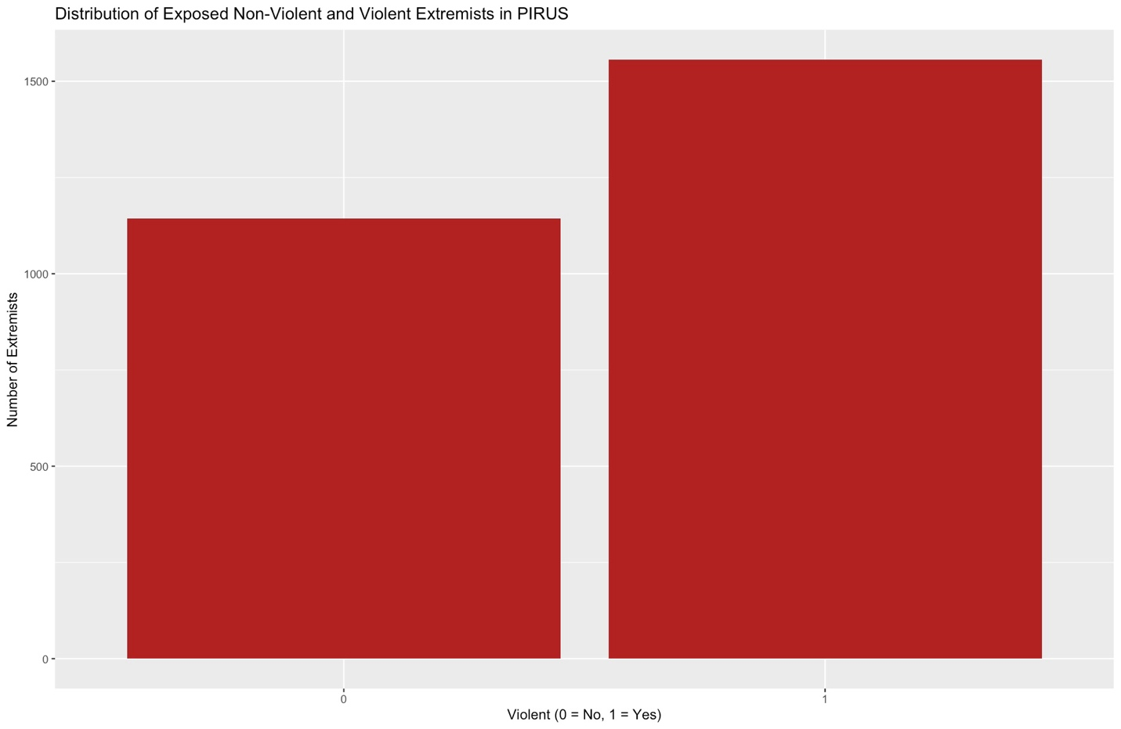

Figure 2:
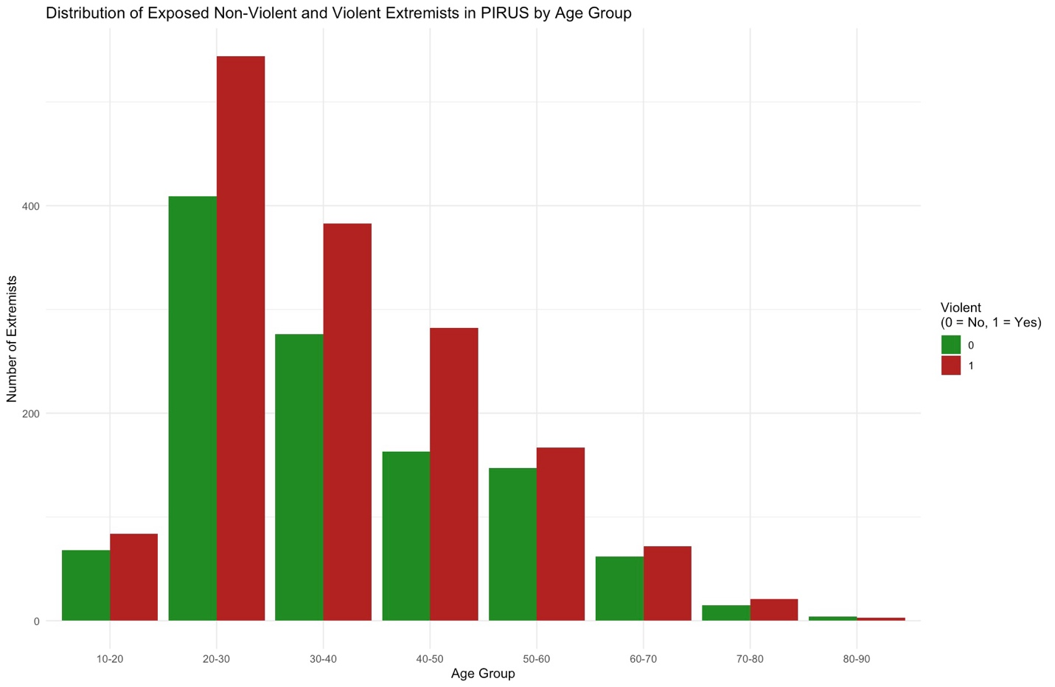

Figure 3:
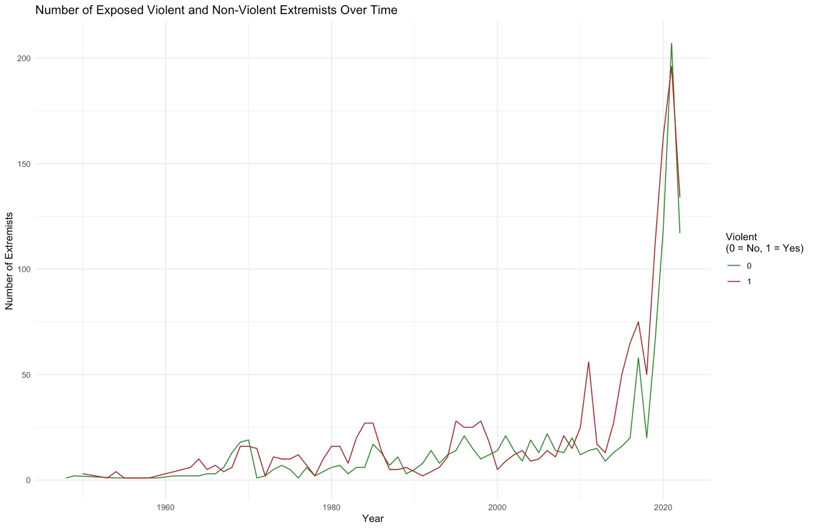

Figure 4:
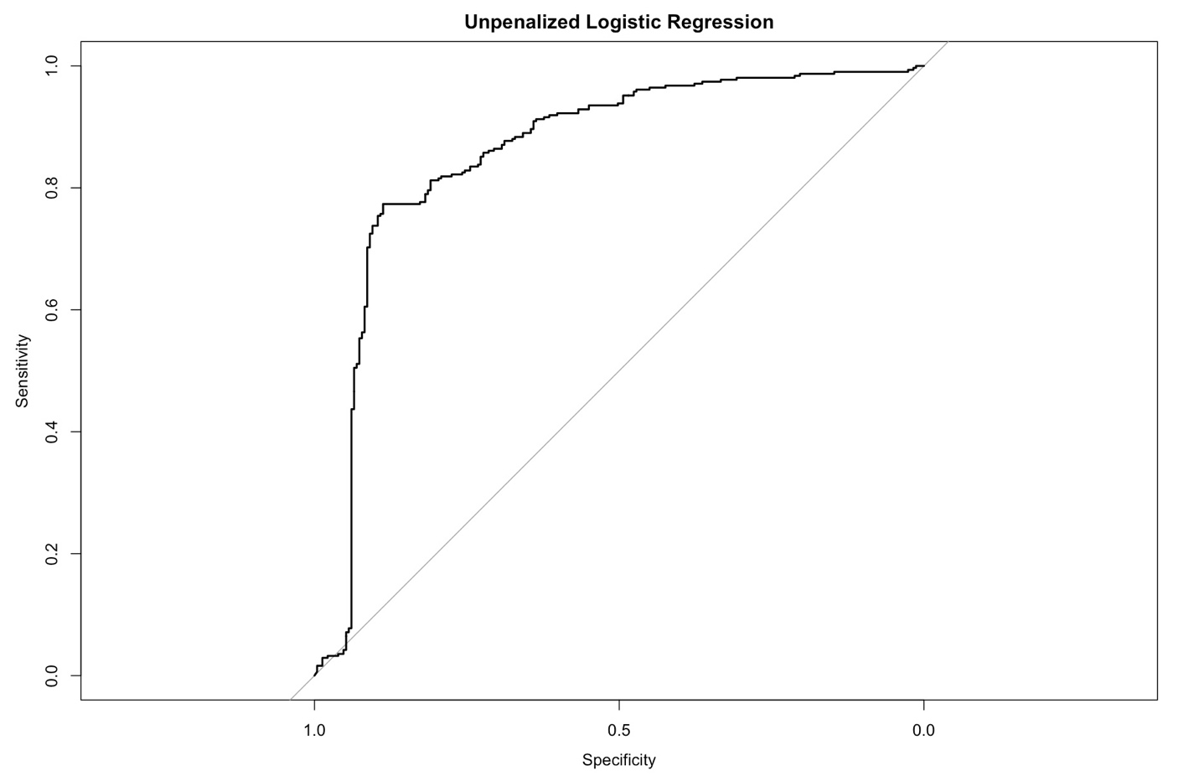

Figure 5: LASSO Cross-Validation Lambda Plot
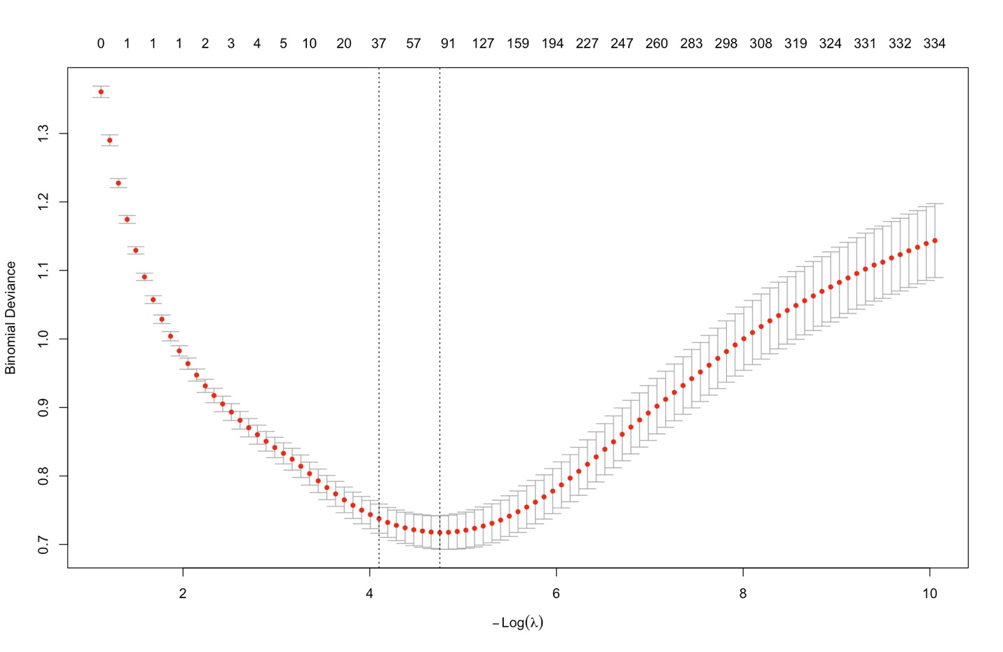

Figure 6:
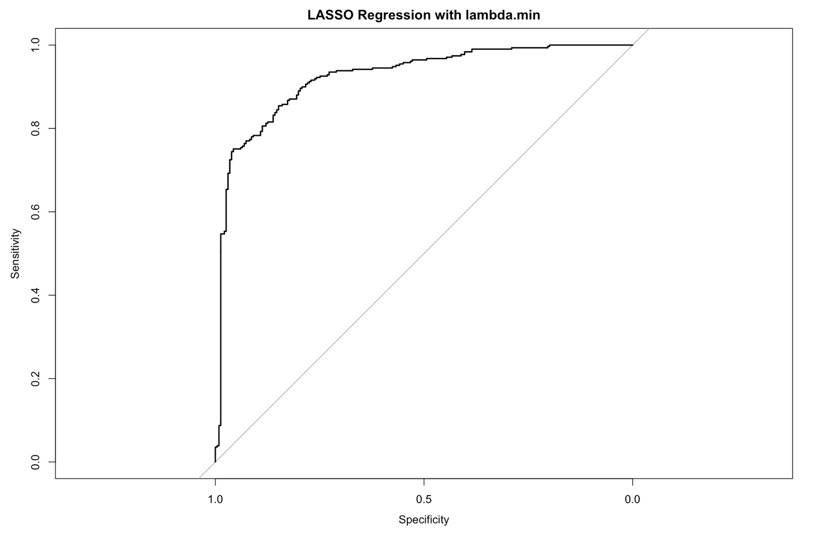

Figure 7:
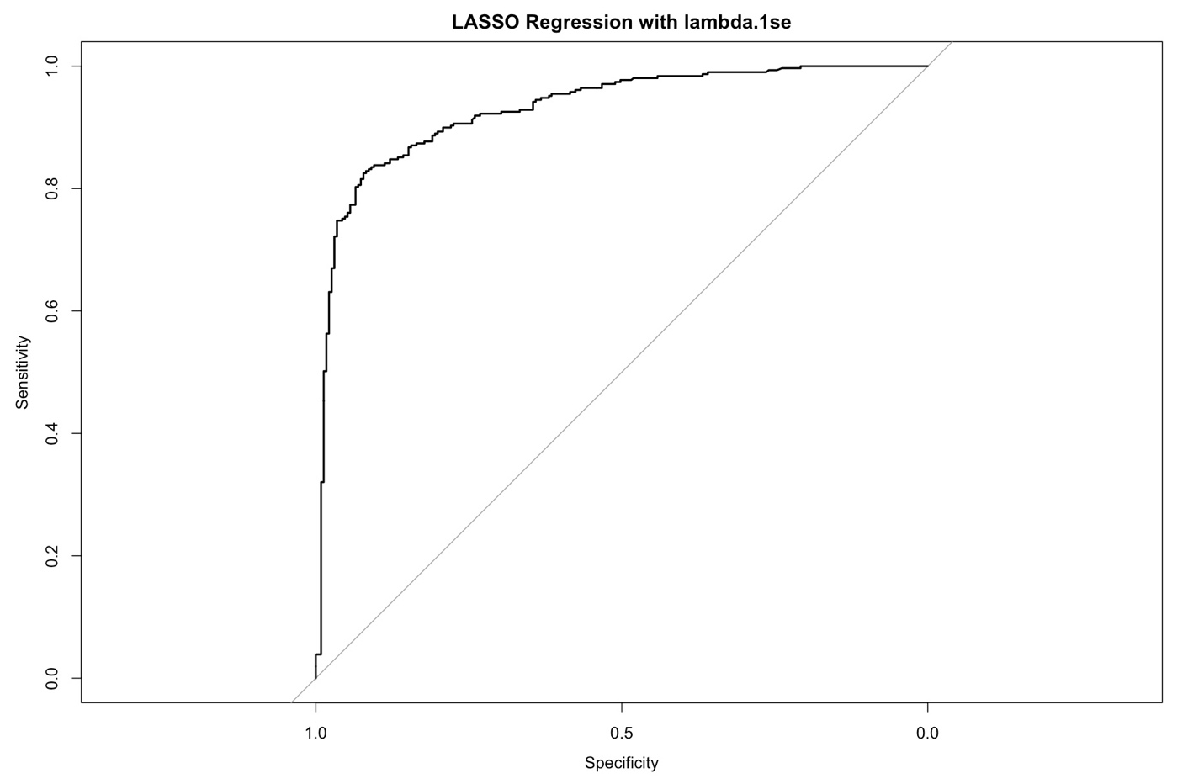

Figure 8: Ridge Cross-Validation Lambda Plot
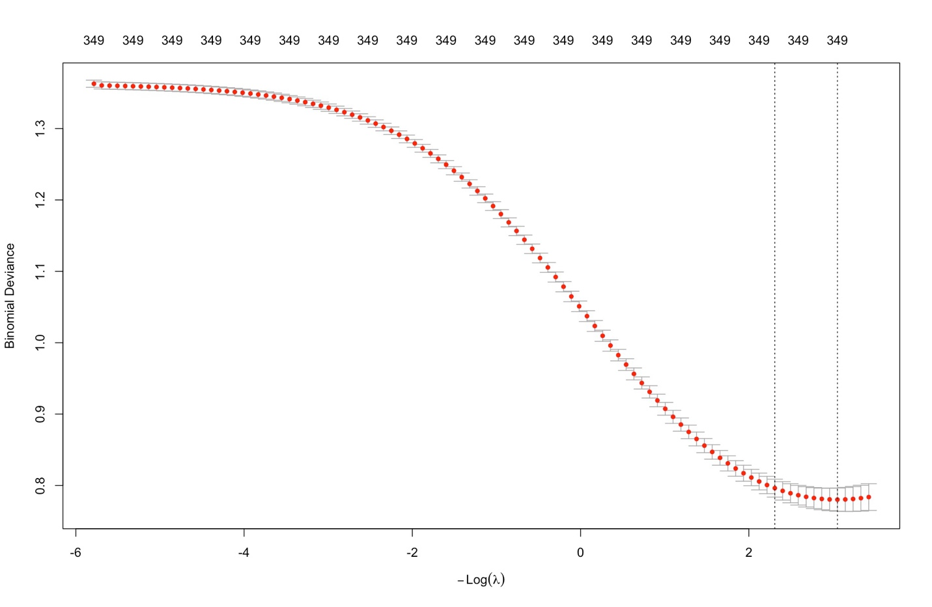

Figure 9:
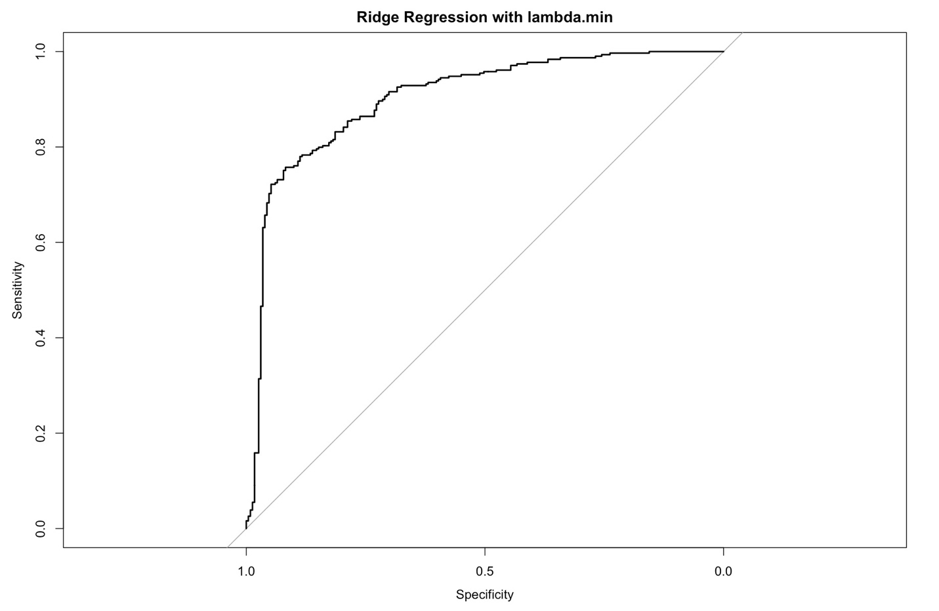

Figure 10:
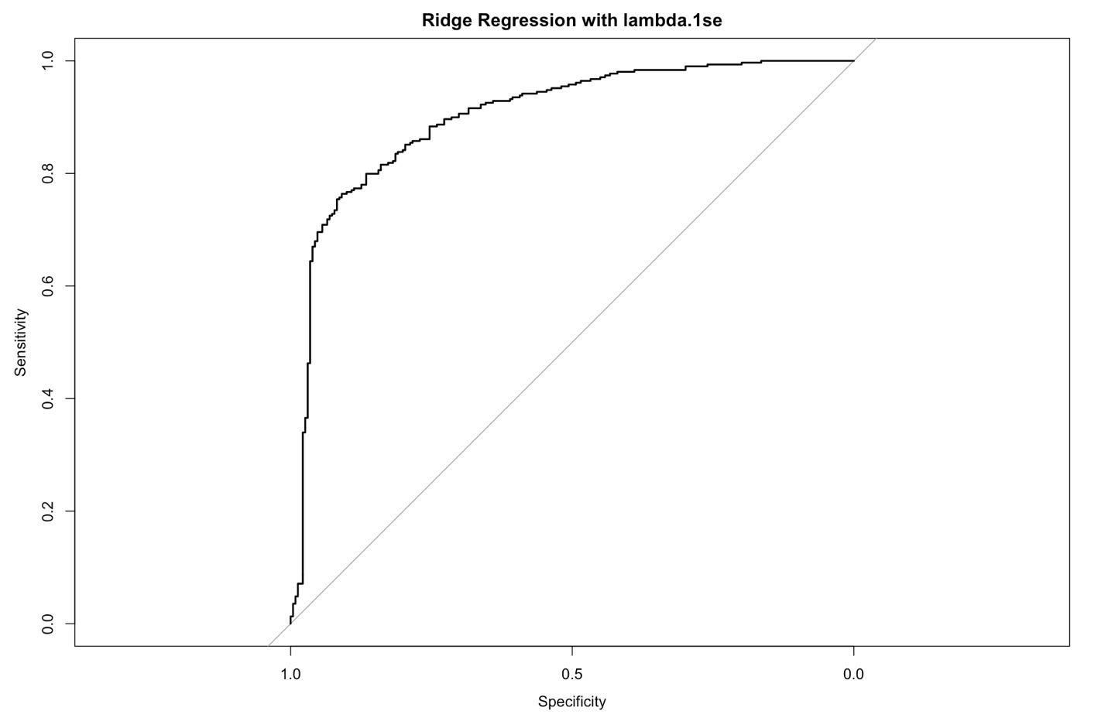

Figure 11: Elastic Net Cross-Validation Lambda Plot
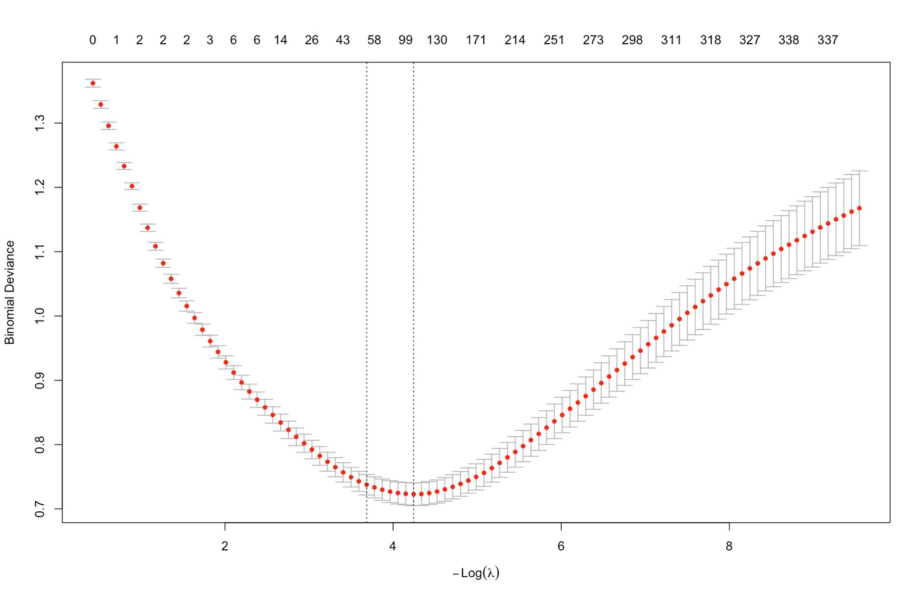

Figure 12:
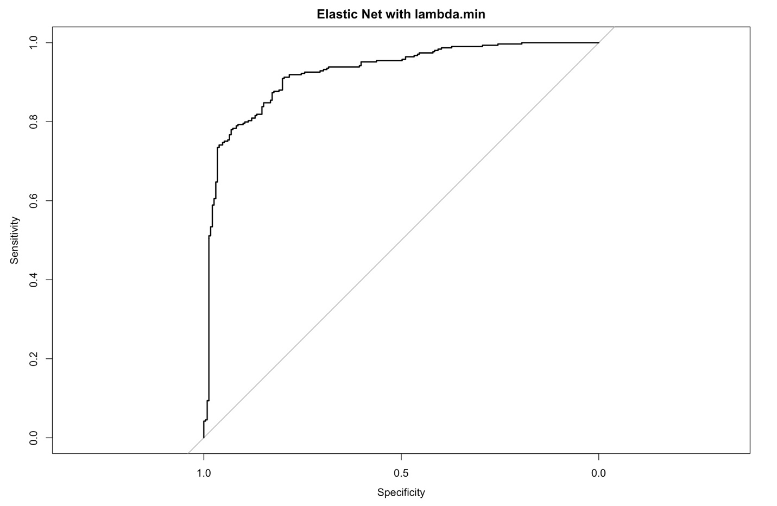

Figure 13:
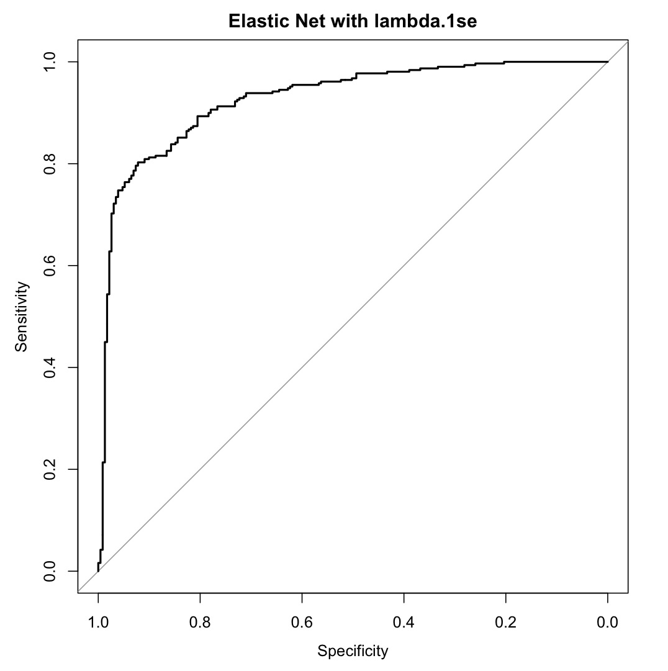

Figure 14: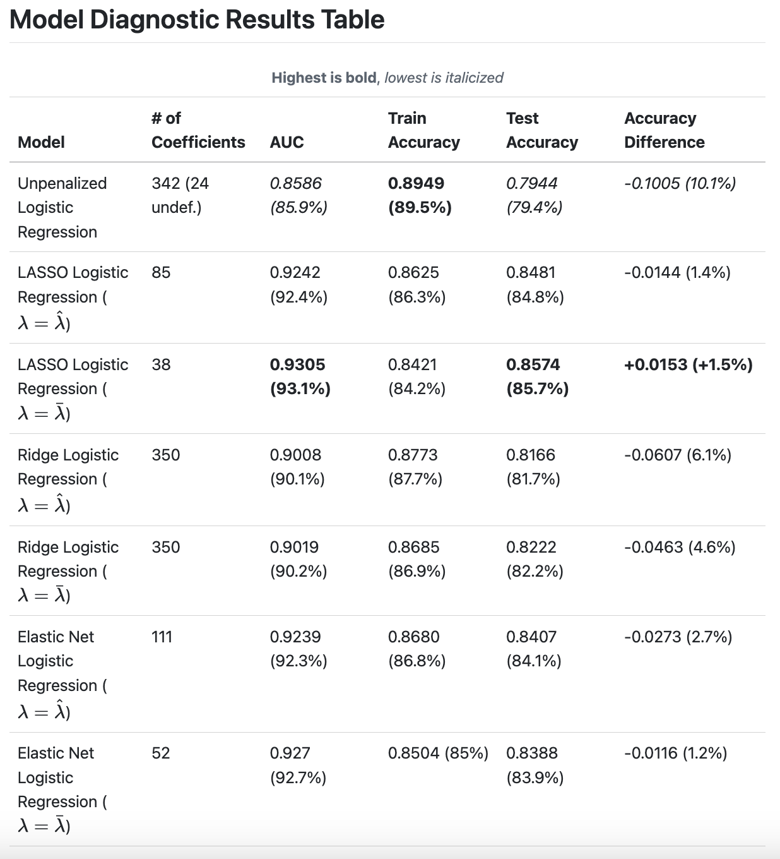

Figure 15: Best Model Coefficients